**Inventory Number API Developer Guide**

**Interface:** Restful Web Service

**Authentication Method:** Basic

**URL Pattern:** http://myvip.cattelecom.com:8080/InventoryNumber/rs/{action}/{msisdn}

**Action: Check Status**

**End Point:** http://myvip.cattelecom.com:8080/InventoryNumber/rs/status/{msisdn}

**Method:** GET

**Example Request:**

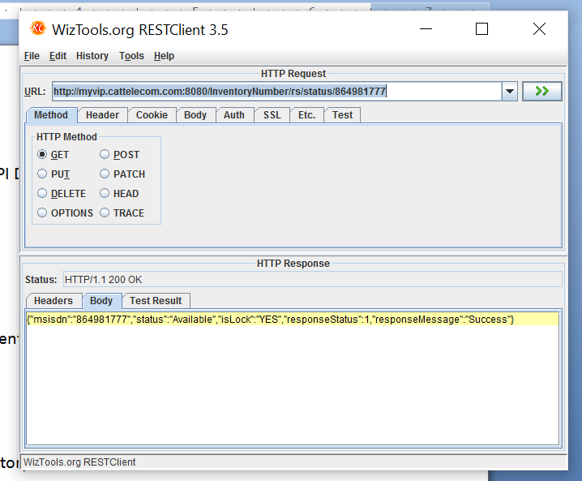

**Action: Lock Number**

**End Point:** http://myvip.cattelecom.com:8080/InventoryNumber/rs/lock/{msisdn}

**Method:** POST

**Example Request:**

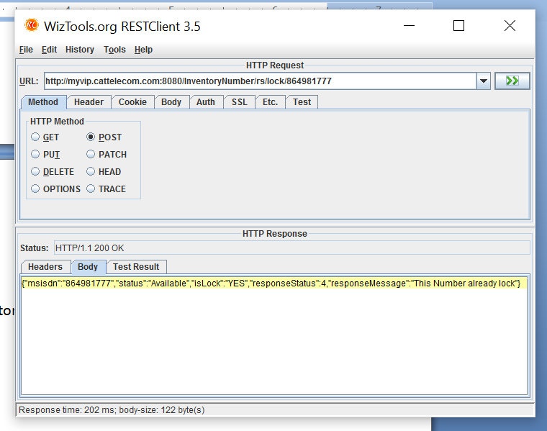

**Action: Unlock Number**

**End Point:** http://myvip.cattelecom.com:8080/InventoryNumber/rs/unlock/{msisdn}

**Method:** POST

**Example Request:**

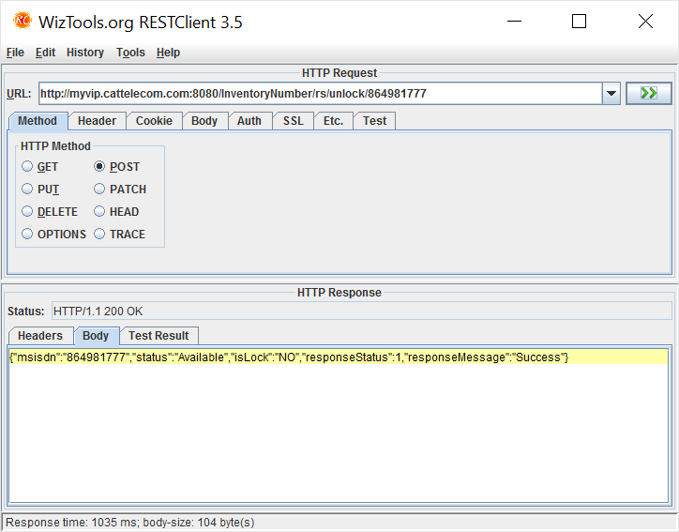

**Action: Check CRM Blacklist**

**End Point:** http://myvip.cattelecom.com:8080/InventoryNumber/rs/crm/blacklist/{identificationNumber}

**Method:** GET

**Description :** Verify Blacklist Customer Account by Identification Number

**Example Request:**

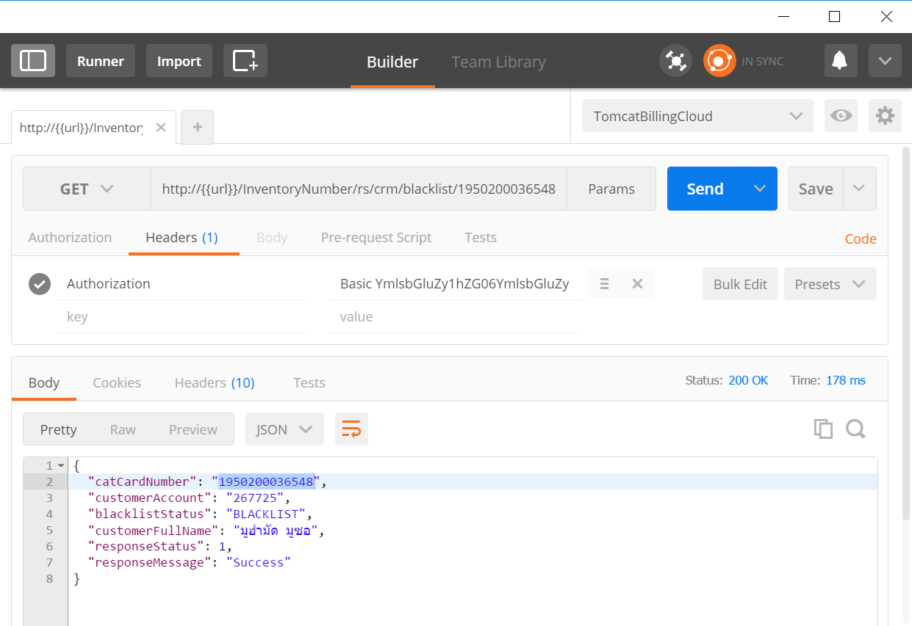

**Response Attribute:**

|  |  |  |
| --- | --- | --- |
| Attribute | Description | Sample |
| catCardNumber | เลขบัตรที่ใช้อ้างอิง | 1950200036548 |
| customerAccount | หมายเลข Customer Account (CA) | 267725 |
| blacklistStatus | สถานะ Blacklist (null = ไม่ติด Blacklist) | BLACKLIST |
| customerFullName | ชื่อเต็ม (แสดงเมื่อติด Blacklist) | มูฮำมัด มูซอ |
| responseStatus | สถานะการเรียกใช้งาน API | 1 |
| responeMessage | รายละเอียดสถานะ | Success |

**Action: Aging Status**

**End Point:** http://myvip.cattelecom.com:8080/InventoryNumber/rs/aging/externalId/{msisdn or imsi}

**Method:** POST

**Example Request:**

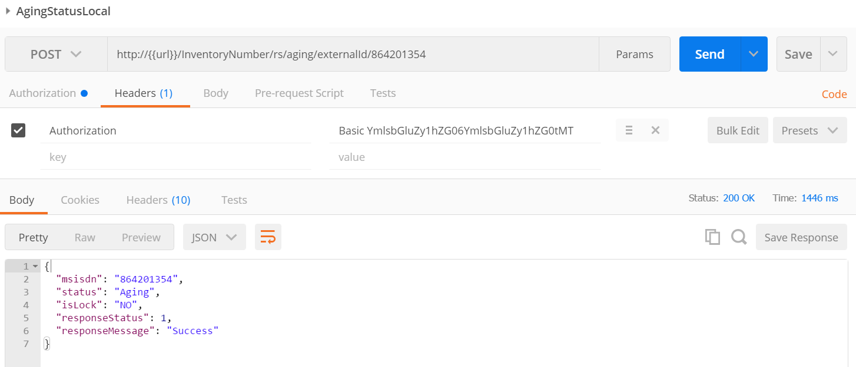

**Action: Aging Status by ICCID**

**End Point:** http://myvip.cattelecom.com:8080/InventoryNumber/rs/aging/iccid/{iccid}

**Method:** POST

**Example Request:**

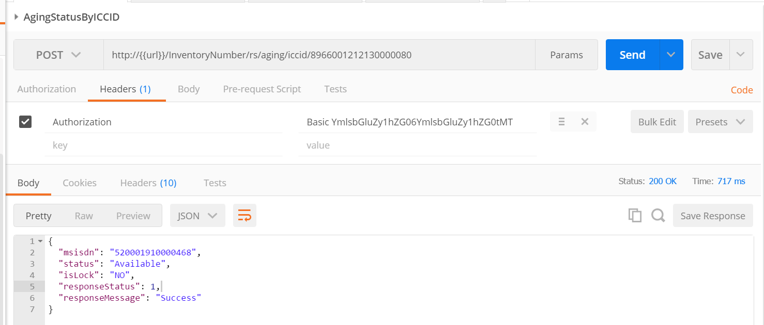

**Action: Force Update Last Status**

**End Point:** http://myvip.cattelecom.com:8080/InventoryNumber/rs/update/{msisdn}?status={status_id}

**Method:** POST

**Example Request:**

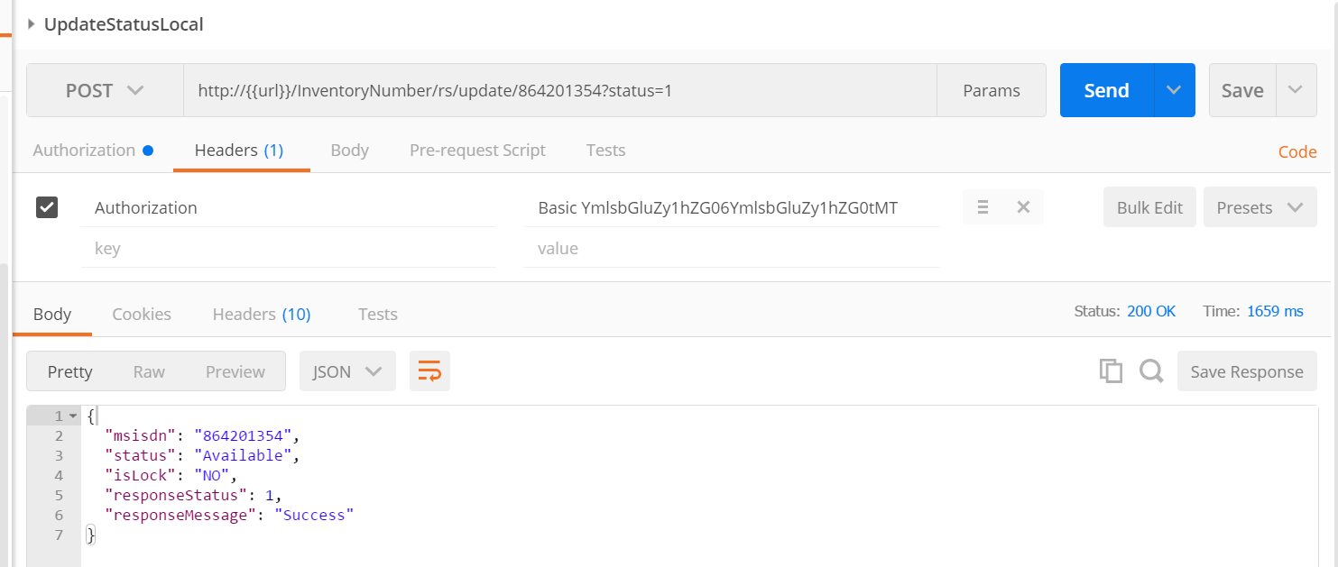

**Action: Check MSISDN Information**

**End Point:** http://myvip.cattelecom.com:8080/InventoryNumber/ rs/info/{msisdn}

**Method:** GET

**Example Request:**

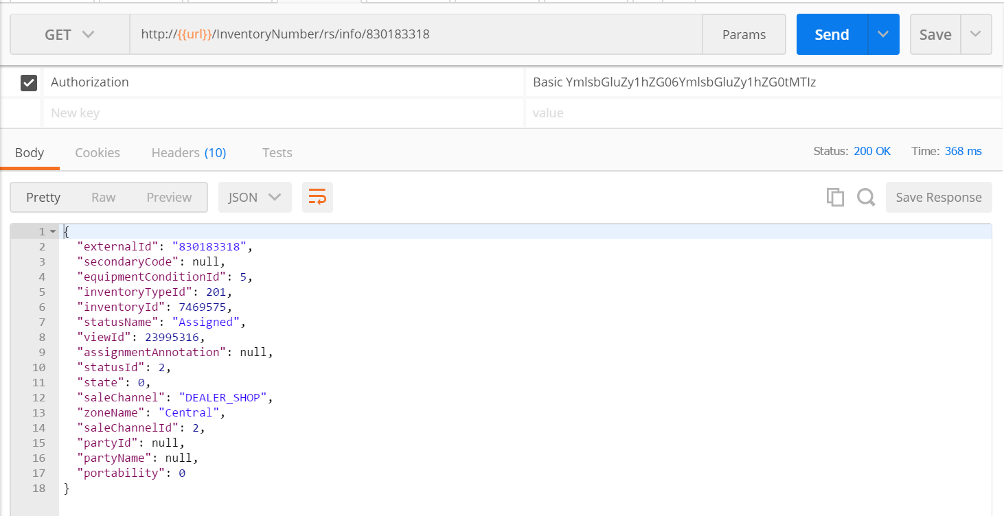

**Action: Force Append Status**

**End Point:** http://myvip.cattelecom.com:8080/InventoryNumber/rs/append-status/{msisdn}

**Method:** POST

**Example Request:**

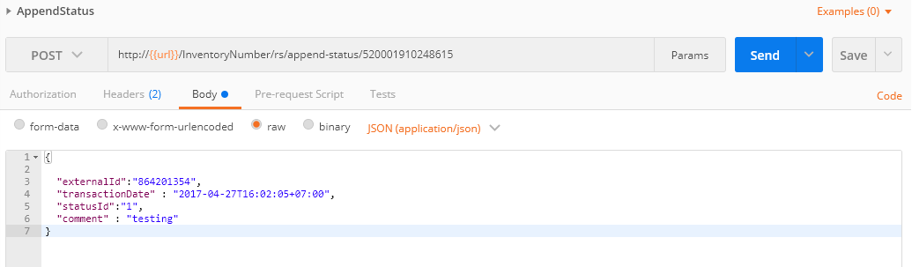

**Note:** การใช้ API ต้องมีการระบุ Username และ Password ที่ระบบได้รับทุกครั้ง

**Example**

